

Project is funded by the European Union

SECOND PRELIMINARY REPORT
ON THE LONG-TERM OBSERVATION
OF THE 2020 LOCAL ELECTIONS IN BIH
(September 7 – November 8, 2020)

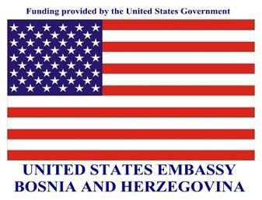

The project is co-financed by:

November, 2020

TABLE OF CONTENTS

1. SUMMARY OF THE REPORT 3
2. METHODOLOGY OF THE LONG-TERM ELECTION OBSERVATION 5
3. ABOUT 2020 LOCAL ELECTIONS 5
4. LONG-TERM ELECTION OBSERVATION 7
4.1. Electoral irregularities and fraud 8
4.2. Work of the electoral administration 15
4.3. Media, civil society, and citizens 19
5. REPORTING ELECTORAL IRREGULARITIES TO COMPETENT AUTHORITIES 20
6. ABOUT “STEP” PROJECT AND “POD LUPOM” COALITION 21

SUMMARY OF THE REPORT
About 2020 Local Elections
- 2020 Local elections are scheduled for November 15, 2020.
- Local elections in Mostar are scheduled for December 20, 2020, for the first time after 12 years.
- In local elections we choose municipal or city mayors, councilors in the municipal councils in the Federation of Bosnia and Herzegovina/municipal assemblies in Republika Srpska and representatives in the Brčko District Assembly – more than 3 200 government representatives at the local level.
- 3 283 380 BiH citizens that are registered in the Central Voter's Register as of October 1, 2020 will have the right to vote in the Local elections. A total of 103 081 voters registered for out-of-country voting.
- 543 political subjects (political parties, coalitions and/or independent candidates) and 30 809 candidates are certified by the Central Election Commission to participate in the elections.
Election irregularities
- Observers of the Coalition “Pod lupom” recorded a total of 1 245 election irregularities from September 9 to November 8, 2020.
- Most of the election irregularities relate to the premature campaign (242), work of public employees for election purposes (201), misuse of the public resources (163) and trading seats on the polling station committees (85).
- Analysis of the premature campaign-related reports shows that most cases refer to the following political subjects: SDA (24), SNSD (21), SDP (10), SDS (8), HDZ BIH (7), PDP (6), DNS (6), etc.
- The analysis of the reports shows that most cases concerning misuse of the public resources refer to the following political subjects: SNSD (45), SDA (30), SDS (11), HDZ BIH (10), DNS (5), SDP (5), etc.
- Many reports and allegations of misuse of personal data for the purpose of registering the voters for by-mail voting were recorded. The cases refer to thousands of citizens.
- Most of those registered for by-mail voting are from the neighboring countries-Serbia (27 500) and Croatia (19 000).
- There are some radical examples of the number of applications for by-mail voting in BiH municipalities/cities – in Dobretići, a small municipality in Central Bosnia, almost 37% of the total electorate registered to vote by mail.
- Trading for seats on the polling station committees continues – some radical examples come from Zvornik where SNSD has all or the majority of members in at least 15 of 87 polling station committees. Stanari, with less than 8000 voters, is another example where as many as 39 political subjects are registered to participate in the election, which points to the presence of phantom political parties whose goal is to trade seats on the polling station committees.
- Pressure on voters and vote-buying continue – the Coalition's observers reported 77 such cases in 45 municipalities/towns.
- Many allegations of vote-buying were recorded, with the price ranging between 50 and 150 KM.
- Many political subjects redirected their activities to social media networks and the use of other audiovisual tools for political promotion (standard political marketing on traditional media, print promotional material, video clips on social networks, and the like.)
- Pre-election rallies were held contrary to recommendations for the prevention of the spread of Covid-19, without any reactions or sanctions by the competent institutions.
- Abuse of Facebook where this social media was prominently used by candidates and political parties to engage in inappropriate speech.
- The cases of paid premature campaign, allegations of misuse of personal data for by-mail voting, trading seats on the polling station committees, vote-buying and other findings of the observation were filed with the CEC of BiH.
Election administration
- In the period following the announcement of the elections, the CEC of BiH held more than 50 sessions.
- The CEC's sessions are open for the public and livestreamed on the CEC’s official YouTube channel;
- The 2020 Local elections are organized in the context of the Covid-19 epidemic; the CEC published its instruction for organization and conduct of the elections in light of the epidemic followed by the voting procedures for persons positive for Covid-19 or those in isolation.
- The Local election commissions for the most part respect the deadlines set forth in the electoral calendar, and the challenge is to arrange the polling stations in line with the Covid-19 instruction to provide sufficient protective gear and disinfectants.
- The deadlines set forth in the electoral calendar were violated in 25 cases by as many as 24 local election commissions.
- Pod Lupom observers recorded that at least 58 objections to the electoral process had been filed with the local election commissions in 33 municipalities/towns.
- Pod lupom observers have had correct cooperation with the Local election commissions.

2. METHODOLOGY OF THE LONG-TERM ELECTION OBSERVATION
The “Pod lupom” Coalition observes the entire electoral process in BiH in the 2020 Local elections. This implies all phases of the electoral process, from the day on which the elections are announced until the publication of final and confirmed elections results. For that purpose, the long-term election observation was conducted during the period September 7 to November 20, 2020. The long-term observation serves to monitor the overall electoral process in order to provide a comprehensive picture of the broadest possible spectrum of the election-related activities, not only the Election day-related activities.

The Coalition “Pod lupom” conducts observation of the 2020 Local elections in cooperation with 85 civil society organizations, informal groups, and activists across BiH and with 100 long-term observers (LTO) covering all 143 basic electoral units in BiH (municipalities, cities and the Brčko District. LTOs observe the sessions of all local election commissions in BiH, the activities set forth in the electoral calendar, election irregularities and media reporting.

LTOs make weekly reports of their activities and have thus far sent 1 284 regular reports on the key findings of the observation effort. The Pod lupom LTOs have thus far held 1 677 meetings with various actors of the electoral process (electoral administration, political subjects, institutions, police administration, civil society organizations, the media and others) with an aim of making an objective assessment of the electoral process in BiH. The LTOs' reports are a backbone of this preliminary report.

In addition to monitoring the work of the municipal/city election commissions, the Coalition has observed the work of the CEC of BiH since the Coalition's establishment in 2014. On Election Day of the 2020 Local elections in BiH, the Coalition will deploy up to 3 000 observers to the polling stations across the country.

3. ABOUT 2020 LOCAL ELECTIONS
The 2020 Local elections will take place on Sunday, November 15, 2020, while the City of Mostar will hold its local elections on December 20, 2020, for the first time after 12 years. On November 15, BiH voters directly elect the following:
- Councilors in 64 municipal and 14 city councils in the Federation of Bosnia and Herzegovina
- Councilors in 56 municipal and 7 city assemblies in Republika Srpska
- 120 mayors
- 22 city mayors
- Representatives in the Assembly of the Brčko District
The Mayor of the Brčko District of BiH is elected indirectly by the District's Assembly. The Mayors of Sarajevo and Mostar are elected indirectly. The Mayor of East Sarajevo (East Sarajevo is made up of six municipalities) is elected directly for the first time, which means that the voters in East Sarajevo will receive three ballot papers (city mayor, municipal mayor and city's assembly).
The Central Election Commission of BiH certified 543 political subjects to participate in the elections (political parties, coalitions and/or independent candidates. Furthermore, the CEC certified 30 809 candidates and 425 mayoral candidates, whereof 29 (6.82%) are women and 396 (93.18%) are men. The CEC certified 196 representatives of national minorities wherefor 40 (20.41%) are women and 156 (79.59%) are men and 30 188 candidates for municipal/city councils/assemblies and Assembly of Brčko District whereof 12 753 (42.27%) are women and 17 415 (57.73%) are men. Curiosity is that 9 basic electoral units have only one certified mayoral candidate.
In the elections for the municipal level, unlike for the higher level, the representatives of 17 national minorities in BiH are guaranteed representation. The Election Law of BiH guarantees seats for the members of the national minorities that according to the latest Census made up more than 3% of the population in a given electoral unit. In the 2020 Local Elections, national minorities in 21 municipalities/cities in BiH are guaranteed a total of 23 mandates. In the general election race in BiH, there are no guaranteed seats for the members of national minorities.
A total of 3 283 380 BiH citizens that are registered in the Central Voter's Register as of October 1, 2020 will have the right to vote in the 2020 Local elections. A total of 103 081 voters registered for out-of-country voting.

A total of 5 759 polling stations have been formed including 388 mobile teams. This is the regular number of mobile teams, while the number of specially formed Covid-19 mobile teams will be known after the elections.
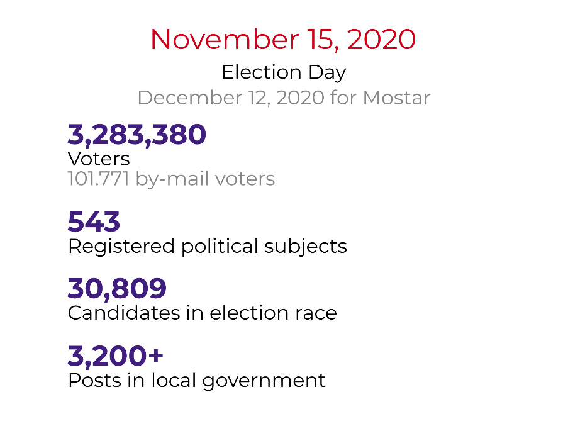
Infographic 1 – Summary of 2020 Local Elections

4. LONG-TERM ELECTION OBSERVATION
In the pre-election period, Pod lupom observes the work and sessions of the local election commissions, activities set forth in the electoral calendar, observance of the deadlines, electoral irregularities, and the media coverage. During the monitoring period, September 7 to November 8, 2020, the Pod lupom observers recorded a total of 1 245 various electoral irregularities.
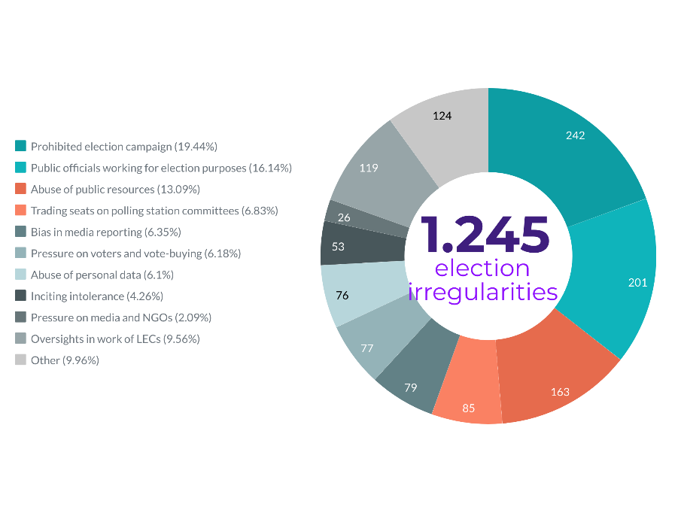
Graph 1 – Total number of electoral irregularities by type

4.1. Electoral irregularities and fraud

4.1.1. Election campaign
The Election Law of BiH defines the election campaign as a 30-day period before the Election day during which a political subject informs the voters and the public about their programs and candidates for the forthcoming elections.
The election campaign for the 2020 Local Elections officially began on October 16, 2020. Any form of paid political advertising and pre-election activities of the political subjects is not allowed before this date except for the holding of internal gatherings of authorities and statutory bodies of the political subjects within the period between the day when elections are announced and the day of official start of the election campaign.
Yet, as in the previous election cycles, it is recorded that many political subjects execute their activities before the official start of the election campaign, especially in the segment of sponsored advertising on social media and display of posters/billboards in the places intended for paid advertising. In addition to these sponsored social media advertising activities examples, in some cases it was recorded that a vast majority of political subjects launched their campaign activities in the field, engaging with voters, publishing posts on their personal or political party social media profiles. The Coalition’s observers recorded 242 cases of prohibited campaign in 65 municipalities/cities across BiH. The analysis of the premature campaign-related reports shows that most reports refer to the following political subjects: SDA (24), SNSD (21), SDP (10), SDS (8), HDZ BIH (7), PDP (6), DNS (6), etc. It is encouraging that the Central Election Commission of BiH imposed a considerable number of fines for engaging in the premature campaign on Facebook.

The election campaign for the 2020 Local elections was characterized by the new emerging circumstances related to the Covid-19 epidemic. It is evident that many political subjects redirected their activities to social media networks and the use of other audiovisual tools for political promotion (standard political marketing on traditional media, print promotional material, video clips on social networks, and the like), a door-to door campaign, street actions, etc. One characteristic in these local elections and in this election cycle is a sharp rhetoric at the local level, as recorded in many municipalities/cities where the campaign was characterized by “poster warfare”, bots on social media and launching portals to discredit political opponents, and if needed, even for the purpose of evoking war traumas and raising ethnic tensions. There were even political rallies, contrary to all recommendations for prevention of the spread of Covid-19, and without any reactions or sanctions by the competent authorities.

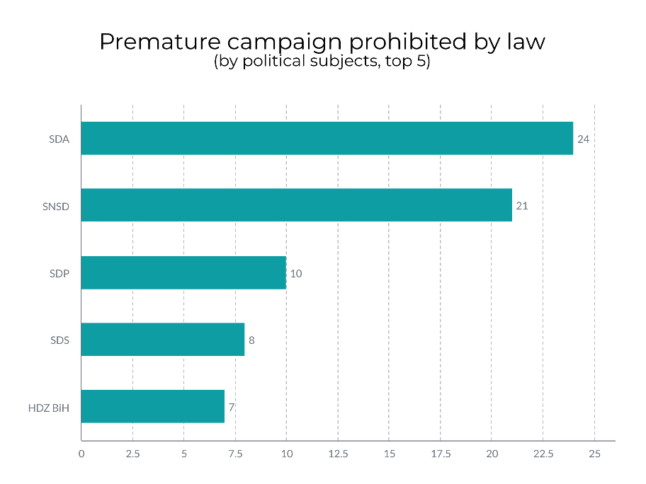
Graph 2 – Premature campaign cases by perpetrators/political subjects (top 5)

4.1.2. Accuracy of the Central Voter's Register (CVR)
The registration of voters in BiH has been passive since 2006, while the active registration is still in place for the voters who vote outside Bosnia and Herzegovina. A total of 3 282 380 voters are registered in the CVR as of October 1, 2020.

The Coalition’s observers recorded suspicions concerning the accuracy of the voter's register in 17 municipalities/cities in BiH⁴. A high number of cases of registration/deregistration of voters implying the change in the number of voters of more than 5% in relation to the total number of registered voters were recorded in 7 municipalities (Srebrenica, Nevesinje, Trnovo (FBiH), Bratunac, Istočni Drvar, Višegrad and Žepče). There were no recorded cases of a large number of the deceased on the voter's registers, as it was the case in the previous election cycles. These were incidental cases.

4.1.3. Illegal trading of seats on the polling station committees
The Election Law of BiH provides that the political subject certified for participation in the election will have only one representative in the composition of a polling station committee. Despite this clear provision, the political subjects frequently reach for different means to get hold of as many seats on the polling stations committees as they can by trading the seats and/or by paying for them to those political subjects that do not have strong interests in certain electoral units. This represents a violation of the law.
The Coalition's observers reported allegations of 85 cases involving the trade of seats on the polling station committees in 36 municipalities. From the list of the political subjects certified to participate in the Local elections, it is evident that there is an increase in the number of political subjects in BiH applying for participation in the elections in the basic electrical units in which they do not have any activity, municipal committee or office space. They do not event have serious plans to compete in the election race. They apply with only one candidate, which may point to a conclusion that they are doing this with a purpose to trade seats on the polling station committees. These phantom political subjects serve primarily for illegal control of the polling station committees' seats.
According to the preliminary surveys, they are in the majority relative to the total number of the political subjects. For example, in Rogatica, 15 political subjects registered only one candidate. Alliance for Stari Grad Sarajevo, an exclusively locally oriented party, certified the lists with only one candidate in 9 of 13 municipalities/cities in Tuzla Canton; local political party in Herzegovina Čapljina Independent Party – Čapljina in my heart has only one candidate on the list in 5 municipalities/cities in Tuzla Canton. By looking at the lists of the polling station members in Derventa proposed by the political subjects that do not participate actively in the political life of Derventa (Hrvatski blok -Croatian Block, Lijevo krilo -Left Wing, Krug -Circle, Narodni pokret Banjaluka zove-People's Movement Banja Luka is calling, Zavičajni socijaldemokrati – Regional Social Democrats, Otadžbinska stranka – Homeland Party, DCRS, Pokret Volim Srpsku- Movement I Love Srpska), it can be inferred that the proposed members have close ties with position and opposition parties participating in the elections in this basic electoral unit.

The Coalition Pod Lupom has repeatedly over the years warned about this wide-spread irregularity. It is evident that there is a need to change the legal framework that regulates the appointment of the polling station committees in order to end this abuse.

4.1.4. Abuse of Personal Data for the Purpose of Registering Voters for Out-Of-Country Voting
The deadline for voter registration for out-of-country voting was September 1, 2020, after which the CEC registered a total of 101 771 voters. This number increased so the total number of the voters registered for out-of-country voting was 103 081 (after accepting appeals and/or review of the individual appeals). The CEC of BiH has on various grounds rejected applications for out-of-country voting from a total of 27 960 voters. The vast majority of the applications were rejected on the grounds of multiple applications for one person (7 623), more than 6 persons registered at the same address outside BiH (4 760), invalid proof of identity (3 617), lack of proof of residence in BiH (2 700), lack of valid proof of identity (2 567), multiple flaws (2 021), etc. The CEC of BiH received over 5 000 complaints concerning the by-mail voting registration. A significant number of these complaints refer to identity theft i.e., abuse of personal data in vote by mail registration, without citizens’ knowledge. This irregularity represents a criminal act.
Compared to the election cycles in the past six years, the CEC received a record high number of applications for by-mail voting - close to 130 000 applications. The number of rejected applications is also a record high. Particularly troubling is the information concerning the large number of applications for one person as well as the large number of applications for multiple persons from the same address, which can point to attempts to abuse by-mail voting. The CEC of BiH notified the competent bodies (SIPA and Prosecutor's Office) about the possible abuse, seeking their further action. For the purpose of preventing the abuse of by-mail voting, the CEC allowed the public insight in the Central Voter's Register; however, the CEC was later instructed by the Personal Data Protection Agency of BiH to remove the excerpts from the official web page.
The Coalition's observers recorded a total of 76 different cases concerning the abuse of personal data in by-mail voting in 29 municipalities and cities in BiH. The Coalition Pod Lupom was notified of five different types of possible abuse of personal data in registering for by-mail voting relating to hundreds of voters. The Coalition notified the CEC of BiH (see point 5 of this Report).
The largest number of the registered for vote by mail comes from the neighboring countries -Serbia (27 500) and Croatia (19 000). Other countries with more than 5 000 of registered voters are Germany, Austria, Switzerland, and Slovenia.

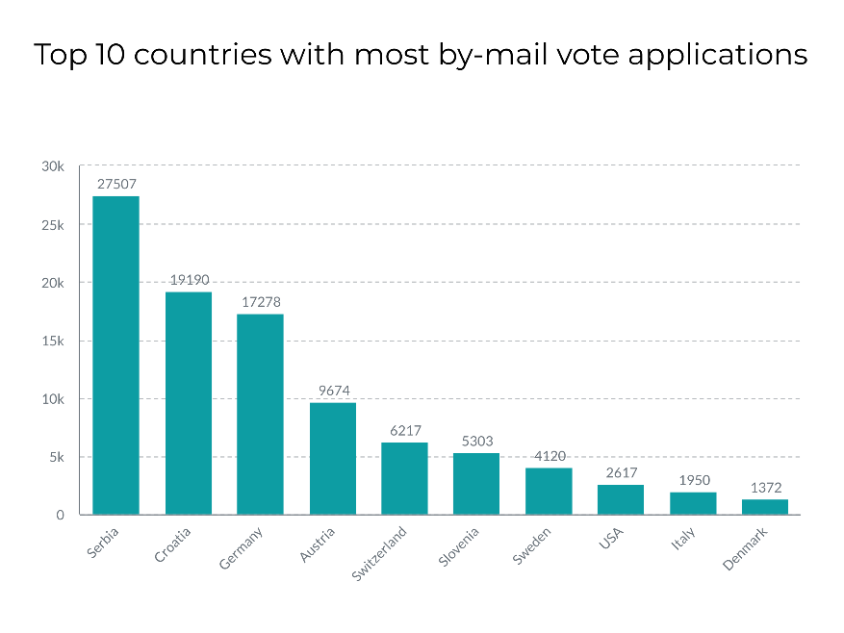
Graph 3 – Number of applications for by-mail voting by country (top 10)
There are some radical examples showing the number of vote by mail applications in BiH municipalities and cities – in Dobretići, a small municipality in Central Bosnia, almost 37% of the total electorate registered to vote by mail. Considering a traditionally low turnout in this municipality (below 50%), in practice this means that on the Election Day more people are going to vote by mail from abroad than in Dobretići. It is interesting that the mayoral candidate that won in the 2016 Local elections in BiH had more votes from the voters from abroad than from those living in Dobretići.
Other municipalities in BiH also have a considerable share of votes by mail in the total electorate. The voters outside BiH can have a significant impact on the outcome of the elections in these local communities.
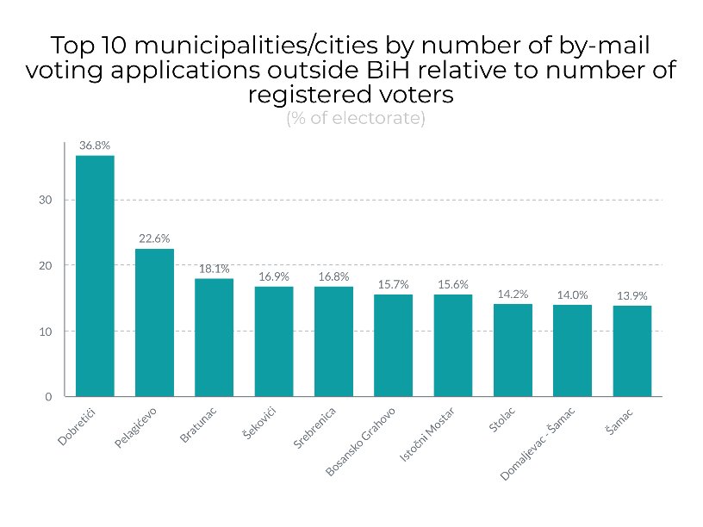
Graph 4 – Number of vote by-mail applications by municipalities/cities as a share in total electorate (top 10)

4.1.5. Illegitimate pressure on voters and vote-buying
Although illegitimate, pressure on voters and vote-buying in elections in BiH have become a usual practice. The Coalition's observers reported 77 such cases in 45 municipalities/cities. These cases refer to the allegations of offering money in exchange for a vote, pressure on employees in the public companies, distribution of packages to citizens, etc. An allegation was recorded that the president of the SNSD Zvornik City Committee exerted pressure on directors of the public companies that they had to “collect a certain number of votes”; in Rudo, the threats that some will lose jobs when “they” come to power“, rumors in Lukavac about buying votes for 50 KM, pressure on employees in municipal administration and public companies in Sapna to support the mayor in the election race, report in Bijeljina that one of the inspection administrations is promising no inspection control if a certain candidate is supported, etc.
The rumors about vote-buying are recorded in several municipalities/cities where the vote price ranges from 50 to 150 KM. Remarks by the long-term observers that such discussions and arrangements are generally accepted and that citizens are not reluctant to sell their votes are raising concerns. Social media play role even in this irregularity, as they are used for offering money in exchange for a vote (for example in Brčko District), of which the CEC of BiH has been notified.

4.1.6. Abuse of public resources and public office for election purpose
The abuse of the public resources and/or public office for election purposes refer to abuse of the budget funds and other public money as well as the abuse of the public companies and appointive public office by political subjects or candidates in the election race. Almost always, the abuse of the public resources is done by those who are entering the election race while already holding public office.

The Coalition’s observers reported 163 cases of abuse of the public resources in 57 municipalities/cities. The reported cases relate mostly to intensification of the public infrastructure works and frequent and intensive visits by public office holders from higher government levels who typically meet or pay visits to those municipalities/cities headed by their party colleagues.

The analysis of the reports shows that most of the cases concerning the abuse of the public resources refer to the following political subjects: SNSD (45), SDA (30), SDS (11), HDZ BIH (10), DNS (5), SDP (5), and other political subjects. A case was recorded in Drvar where the current mayor gave 100 KM to pupils; nontransparent allocation of more than 600 000 KM of agricultural incentives in Bijeljina, which is investigated by the District Prosecutor's Office in Bijeljina; introduction of the financial support for freshmen with residence in Ljubuški in amount of 500 KM and increase of the earlier financial support for seniors; intensified public infrastructure in many municipalities/cities across the country, etc.

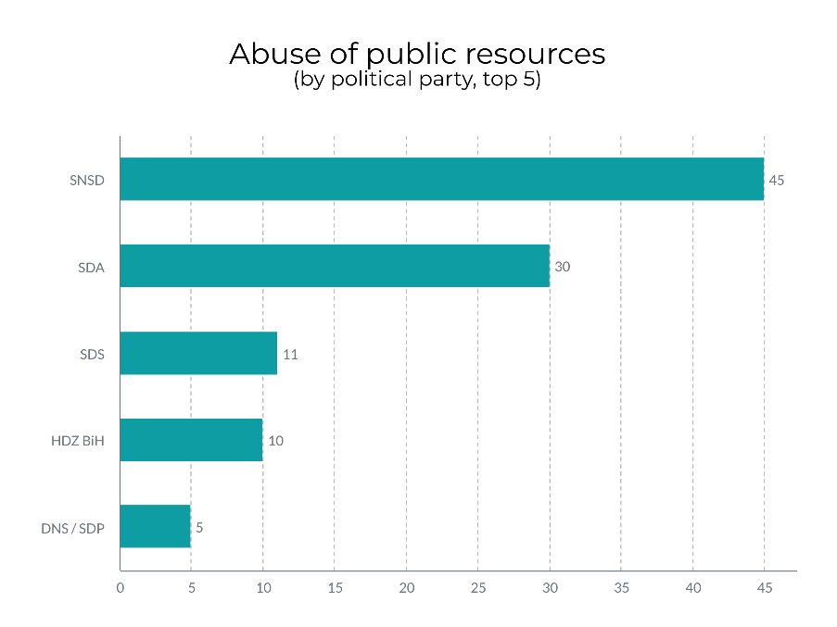

Graph 5 – Abuse of public resources by perpetrator/political subject (top 5)

The work of public officials and of other employees in the public administration or public companies for election purposes can be regarded as the abuse of the public resources. The Coalition's observers recorded 201 such cases in 48 municipalities/cities in BiH. An example of special arrogance took place in East Sarajevo, where, according to the media, a street was blocked to ensure safety of the Chairman of the Council of Ministers of BiH while visiting one of the restaurant with his party colleague, a minister in the Council of Ministers.

4.1.7. Other irregularities
The cases of inappropriate speech, language or contents that can incite religious, ethnic, or other intolerance, most frequently on the basis of affiliation to a political subject, were recorded in 53 cases in 26 municipalities/cities. The majority of these cases relate to the latter, extremely inappropriate speech or intolerance based on political affiliation. Social media especially Facebook saw not only heated debates but also emergence of new profiles or pages for the sole purpose of naming and shaming political opponents. In Bijeljina, there was an incident of a broken window on the local mosque, which was strongly condemned by the local government representatives.
One case that drew serious public attention was a video jingle of the United Srpska party, which in a stereotypical and offensive manner shows members of the constitutional people and minorities in BiH. The CEC of BiH has assessed this video to be the part of this political subject's election campaign, and that its contents “may convey an unambiguous and direct risk of inciting hatred, instilling of fear and intolerance.” The CEC passed a decision annulling this political subject's certification for participation in the election and imposed a maximum 10 000 KM fine on the leader of the party. The CEC's decision was however appealed to the Appellate Division of the BIH Court. The Court of BiH annulled the CEC's decision allowing the political subject to participate in the elections.
The Coalition Pod lupom recorded 100 different reports of “other irregularities”. A vast majority of these irregularities, over 80%, relate to displaying posters and political promotional materials at prohibited locations during the campaign, “poster warfare”, or the like.
In addition, the Coalition recorded a range of political rallies taking place contrary to the recommendations for preventing the spread of Covid-19, with no reactions by the competent authorities, primarily the police.
The Coalition has thus far received a number of reports by citizens concerning electoral irregularities and inquiries about the protection of voter's right, mostly about voting by mail and exercising the right to vote in an epidemic. The citizens reported individual examples of personal data abuse in registering for by-mail voting and undelivered ballot papers for by-mail voting. Other irregularities reported by the citizens referred to trading of seats on the polling station committees, allegations of vote-buying, political promotional material on prohibited locations.

4.2. Work of the electoral administration

4.2.1. The Central Election Commission of BiH (1)
The Central Election Commission of BiH (CEC) is responsible for organization and conduct of the elections. On May 7, 2020, the CEC called the Local elections, within the legal deadline, and scheduled the elections for October 4, 2020. As the budget of the institutions of Bosnia and Herzegovina was not approved by that time, the CEC passed a Decision on the Postponement of the 2020 Local Elections, setting a new date for the elections – November 15, 2020. The Constitutional Court of BiH was then asked to review the constitutionality of the CEC’s decision, which it rejected saying that it did not have the jurisdiction in this matter. It is within the jurisdiction of the regular Court. The Court of BiH rejected the request as ungrounded, and the November 15 remained the date of the 2020 Local Elections in BiH.
On July 23,2020, following the amendments to Election Law of BiH, the CEC of BiH announced the elections for Mostar, for the first time after 12 years. The elections are scheduled for December 20, 2020.
During the time between the announcement of the elections and the publication of this report, the CEC held more than 50 sessions. The sessions are livestreamed on the CEC's official YouTube channel, allowing the public to have insight into the activities and work of the Commission. In its work, the CEC of BiH monitors the deadlines for organization and conduct of the electoral activities.
As the upcoming elections are taking place in the new emerging circumstances related to the Covid-19 epidemic, in June 2020 the CEC of BiH passed the Instruction on Operations of the Election Management Bodies on the Election day in the Context of the Covid-19 Epidemic. The instruction defines the procedures that should be applied on the Election day for the purpose of protecting the health and lives of representatives of the election administration authorities and voters. In addition, in September 2020, the CEC of BiH adopted amendment to the Rulebook on the procedure of conducting elections in BiH specifying the manner in which persons positive for Covid-19 or those ordered to stay in isolation would exercise their right to vote, setting the conditions for these persons to exercise their right to vote.
However, the November 11 amendments 2020 brought new changes to the Rulebook allowing these categories of voters to exercise their voting right through a special mobile team if they in their application to the competent local election commission also submit a relevant document issued by the competent authority (medical report or order to isolation).Taking into account the situation in the field where competent authorities frequently fail to timely submit these tests or decisions on isolation, or that when sent by post these document often arrive after the period of isolation, there is concern that many of these voters will be hindered or disallowed from voting in election due to the untimely issuance of the relevant documents.
The Pod Lupom Coalition welcomes the CEC's measures such as those for the prevention of Covid-19, the measures set in place to allow the persons positive for Covid 19 or in isolation to exercise their right to vote, the disclose of the excerpts from the Central Voter's Register (even though they were removed in line with the instruction of the Personal Data Protection Agency) or specific sanctions for paid advertising during the prohibited period, which had for the first time been imposed. The CEC's proactive approach in their effort to restore the shaken public trust in the elections in BiH through increasing transparency and timely reviewing electoral irregularities is encouraging and a change for the better compared to the previous years. The CEC has also strengthened their cooperation with civil society organizations observing the elections in BiH, including the Pod lupom independent observers. The Coalition Pod lupom expresses hope that this trend will continue.

4.2.2. Local election commissions (143)
The local election commission (municipal, city and Brčko District) are responsible, inter alia, for designation of polling stations, formation and training of polling station committees, organization of Election Day and compilation of the election results from the polling stations located on their territory. Composition of a local election commission, according to the Election Law of BiH and Law on Gender Equality, shall reflect gender representation of at least 40% of members of the underrepresented gender. 12 local election commissions failed to comply with this gender requirement. Also, two local election commission are not operating in full capacity, even though there are only two days left before the Election Day.
The majority of local election commissions carry out adequate preparations for the conduct of the elections. Instruction on the method of work and reporting of election commission of basic constituency in Bosnia and Herzegovina more tightly regulates the work of the local election commissions. The Instruction, inter alia, sets forth the adoption of Rules of Procedure by the local election commissions, which was fully observed by all local election commissions in BiH. The Instruction also provides that the local election commissions may appoint secretary and/or technical secretary, which was done by 82 (57.34%) local election commissions, which is an increase compared to the 2018 general elections in BiH.

The vast majority of local election commissions regularly holds weekly meetings. During the period covered by this report, the local election commissions held at least 1 128 sessions. Five local election commissions faced difficulties in their work in terms of inadequate working conditions. The Pod lupom long-term observers were informed by 14 local election commissions that their members had not attended the CEC's training for local election commissions.
The Coalition's observers recorded that 58 objections to the electoral process were filed with the local election commissions in 33 municipalities/cities. The objections mostly relate to the lottery for members of the polling station committees and voter registration for by-mail voting. The Central Voter's Register is not available in Ključ Municipality.
According to the latest information from the Central Election Commission of BiH, of November 12, 2020, regarding the local election commissions’ implementation of the Instruction on Conduct of Elections at time of Covid-19, it is stated that after telephone calls and direct contacts between the CEC's staff and members of the local election commissions only four election commissions (Han Pijesak, Kreševo, Ravno and Vitez) failed to secure the necessary materials; however, two of them pledged to do so before the Election Day (Ravno and Vitez). This is encouraging given that this information only 24 hours earlier indicated that as many as 30 local election commission said that they either did not have sufficient funds or that implementing this instruction was an obligation of other authorities, and 42 local election commissions failed to submit any information regarding their implementation of the measures.
The information from the field indicates similar situations where a vast majority of the local election commissions have secured minimum basic materials such as disinfectants and protective gear (masks and gloves) in order to protect the health and prevent the spread of the virus at polling stations. It raises concerns that 23 local election commissions stated that they did not have at their disposal sufficient materials and equipment to comply with all Covid-19 measures prescribed by the CEC BiH. The Coalition's observers will monitor the implementation of the prescribed epidemiological measures on the Election Day. As regards observance of the deadlines set forth in the electoral calendar, the deadlines were violated in 25 cases by as many as 24 local election commissions.
It was registered that 11 local election commissions failed to disclose the documentation confirming the appointment of the polling station committees, even though it is their obligation. It was established that the local election commissions in 7 municipalities/cities failed to complete training for members of their polling stations within the legal deadline, by November 8, 2020.
Four local election commissions failed to within the legal deadline select the polling station locations and submit the certificates to the CEC BiH, while 3 local election commissions failed to appoint members to the polling stations within the given legal deadline.
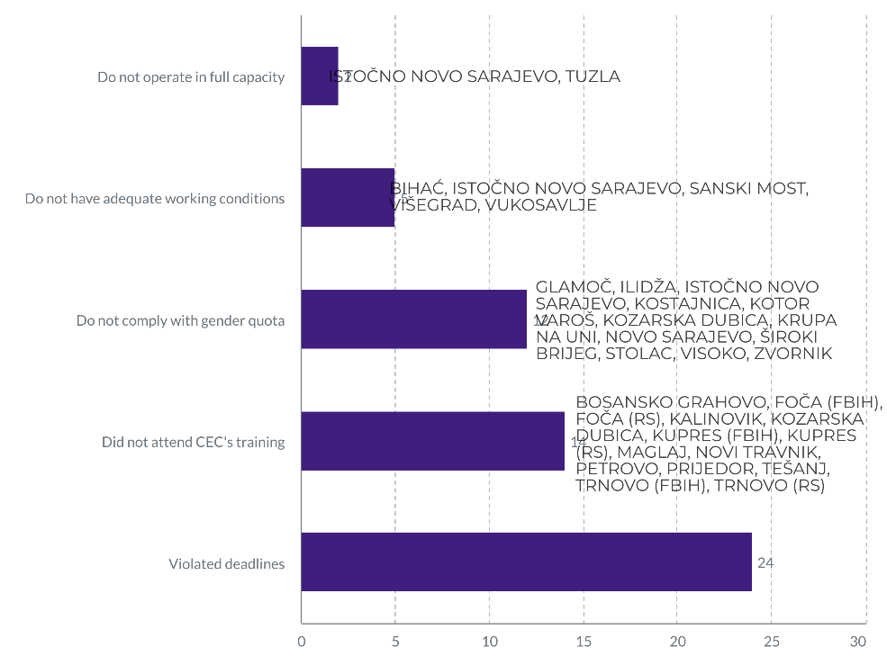
Graph 6 – Information on work of local election commissions

4.3. Media, civil society, and citizens

4.3.1. Media reporting
The Coalition's long-term observers monitored the local and regional media reporting. The observers recorded the cases of bias in media reports usually either positively or negatively reporting on certain political subjects and conveying inappropriate speech of public officials or candidates in the election race. 79 such cases were recorded in 49 municipalities/cities. Different type of pressure on media was recorded in 19 municipalities/cities.

4.3.2. Civil society and citizens
Indirect pressure on civil society organizations, including pressure on the Coalition's observers were reported in 7 municipalities/cities. Out of concern for personal safety of observers in the field, the Pod lupom Coalition will not name specific examples of pressure on the Pod lupom observers. All cases will be addressed internally.
Earlier, the Coalition recorded coordinated attacks by political parties on the independent and non-partisan character of the Coalition's election observation mission when they attempted to infiltrate their partisan activists among the non-partisan observers. The Coalition Pod lupom most strongly condemns such practices by certain political parties.
The Pod Lupom observers report that in some municipalities civil society organizations are being used to promote political subjects in a way that it may have harmful effects on the status and aspirations of the majority of civil society organizations to work in line with their programmatic goals, without pressures coming from the ruling political parties or those aspiring to win elections. Besides the fact that the activities of some associations or political subjects intending to abuse civil society organizations seriously undermine their mission and purpose, such practices are contrary to the laws on associations and foundations in BiH that clearly provide that the goals and activities of the associations and foundations will not include engagement in election campaigns of political parties and candidates.

5. REPORTING ELECTORAL IRREGULARITIES TO COMPETENT AUTHORITIES
Premature campaign on social media (Facebook), political advertising during the time when it is prohibited, trading seats on political station committees, manipulating the electoral process through certification of the so called phantom political subjects for participation in elections and abuse of personal data concerning by-mail voting are the irregularities that the Coalition Pod lupom observers recorded and reported to the CEC of BiH. The allegations of the abuse of personal data have also been reported to the Prosecutor’s Office of BiH.
Until the publication of this report, the CEC of BiH notified of approximately 40 reports on violations of the Election law of BiH, whereof 26 cases of the premature paid election campaign, allegations of abuse of personal data in registering for by-mail voting in five different basic electoral units, attempts of vote-buying in Brčko District, trading of seats on the polling station committees in five different electoral units with evidence showing that members and/or activists of one political subject in the polling station committee fictitiously represent another political subject.

All remarks and other findings of the long-term observation prior to publication of this Report will be timely forwarded by the Coalition Pod lupom to the Central Election Commission for further action.

6. ABOUT “STEP” PROJECT AND “POD LUPOM” COALITION
The Centers for Civic Initiatives (CCI), as the project Coordinator, together with the Centre for Civic Cooperation Livno, Forum of Tuzla Citizens, Association of Citizens "Democracy-Organization-Progress" Prijedor and Institute for Youth and Community Development "Perpetuum mobile" from Banja Luka, as the project partners, as part of Pod lupom – Coalition for Free and Fair Elections are implementing the System Transparency in Election Process (STEP) project funded by the European Union (EU) and cofounded by the Government of the United States of America and the Organization or Security and Cooperation in Europe (OSCE). The STEP project will directly increase the strength and visibility of the civil society organizations (CSOs) to perform citizen election monitoring and support the development of civil society participation in the democratization processes in the country, covering two election cycles in BiH: 2020 Local Elections and 2022 General Elections.
STEP project is looking to strengthen civic participation and empower country – broad CSO movement to support the fair and free elections in Bosnia and Herzegovina, reducing the risk of electoral frauds and manipulations. Boosting citizen interest to take a proactive approach in expressing their free political will is what this project aims to actively contribute to, understanding that the elections represent the essential and most crucial form of citizen participation in democratization processes in the country.
STEP designed a set of activities divided under the 5 components, following the imperative of the CSO capacity building aiming to empower the civil sector to capacitate for further, stronger, and visible, sustainable local citizen election observation activities in the future. The STEP is consisted of the following five project components: 1) Capacity Building and Network Development, 2) Election Observation, 3) Policy Development and Advocacy, 4) Public Outreach and Voters’ Education and 5) Media Monitoring.
The Coalition for free and fair elections “Pod lupom” as an informal coalition of civil society organizations has been active since 2014. Thus far the Coalition observed the 2014 General Election, the 2016 Local Election, the 2018 General Election, and 20 other elections (primary, early, repeated elections and mayoral recall elections). A total of around 10 000 civic observers were engaged in all of the elections. The Coalition has worked with 50 000 citizens, whereof 30 000 young people.
The Coalition's 14 recommendations have been either fully or partially adopted, which contributed to the improvement of the election process. The Coalition Pod Lupom was voted the most trusted actor in the electoral process according to IPSOS’s research from August 2018 (trusted more than electoral administration, political parties, candidates, or media).

Besides the election observation, the Coalition conducts studies and prepares international comparative analyses. The Coalition monitors the sessions of the Central Election Commission of BiH (CEC), organizes roundtable conferences that bring together representatives of legislature, election administration, international and academic community, media, and civil society. The Coalition advocates improvement of electoral process in all of its segments. In addition to the aforesaid activities, the Coalition also educates young first-time voters during the election year to motivate and encourage them to actively participate in the election process.

The project is funded by the European Union

This publication is created with financial support of the European Union (EU).

The responsibility for the content of this document lies solely on the Coalition Pod lupom and does not reflect the official opinion of the European Union.

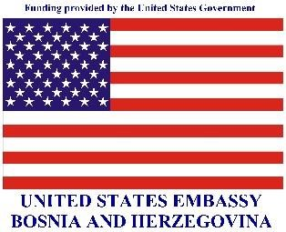

Publication of this report was funded in part by a grant from the United States Department of State.

The opinions, findings and conclusions stated herein are those of the authors and do not necessarily reflect those of the United States Department of State.

The OSCE Mission to Bosnia and Herzegovina supported publication of this material. Any view, statement or opinion expressed in the publication, unless explicitly specified, do not necessarily reflect the official position of the OSCE Mission to BiH.

Political parties - 129; indepedent candidates - 262; coalitions - 72; independent candidate lists-9; independent candidates for national minorities -71
DOMALJEVAC-ŠAMAC, ORAŠJE, TEOČAK, MRKONJIĆ GRAD, JEZERO, OLOVO, GRUDE, RAVNO AND USORA
KRUPA, ODŽAK, LUKAVAC, BANOVIĆI, KALESIJA, KAKANJ, TRNOVO (FBIH), PALE (FBIH), NOVI GRAD, PRNJAVOR, VUKOSAVLJE, SOKOLAC, GRADAČAC, SREBRENIK, TUZLA, ZENICA, PRIJEDOR, GRADIŠKA, BANJA LUKA, TREBINJE AND BRČKO DISTRICT BIH
102 377 voters registered for by-mail voting while 704 voters will vote at diplomatic and consular missions abroad
BANJA LUKA, BIHAĆ,BIJELJINA, BUSOVAČA, BRČKO DISTRIKT, DOBOJ, DRVAR, GORNJI VAKUF -USKOPLJE, GRADAČAC, GRUDE, KOZARSKA DUBICA, KRUPA NA UNI, LIVNO, LJUBUŠKI, MODRIČA, NOVI GRAD, PETROVO, PRIJEDOR, SAPNA, SREBRENICA, STARI GRAD SARAJEVO, STOLAC, TUZLA, UGLJEVIK, VELIKA KLADUŠA, VISOKO, VITEZ, ZAVIDOVIĆI, ZENICA, ILIJAŠ,ŠIROKI BRIJEG, SREBRENICA,VELIKA KLADUŠA, ŽEPČE, CENTAR SARAJEVO, ISTOČNO NOVO SARAJEVO, KOTOR VAROŠ, NOVI GRAD SARAJEVO, NOVI TRAVNIK, PALE (RS), ROGATICA, SANSKI MOST, TREBINJE, VIŠEGRAD, ZVORNIK, CAZIN, ČELINAC, LJUBUŠKI, LUKAVAC, NOVI TRAVNIK, TESLIĆ, HADŽIĆI, NEUM, NOVI GRAD SARAJEVO, NOVO SARAJEVO, PALE (FBIH), PELAGIĆEVO, TRAVNIK, ČELINAC, GRAČANICA, ILIDŽA, TOMISLAVGRAD, VUKOSAVLJE, MOSTAR
BANJA LUKA, BRATUNAC, ČELINAC, HAN PIJESAK, SAPNA, SREBRENICA, BIJELJINA, OLOVO, ŽEPČE, KLJUČ, BUŽIM, NOVO GORAŽDE, RUDO, ČAJNIČE, BRČKO DISTRICT BiH, NOVI GRAD, VIŠEGRAD
CAZIN, LIVNO, SAPNA, SREBRENICA, TRAVNIK, ČAJNIČE, DERVENTA, NOVI GRAD, ROGATICA, ZAVIDOVIDI, ŽEPČE, BIHAĆ, BROD, GRAČANICA, LUKAVAC, BUGOJNO, ILIJAŠ, PALE (FBIH), PETROVO, TOMISLAVGRAD, JABLANICA, KONJIC, NOVI TRAVNIK, PALE (FBIH), TEŠANJ, TESLID, TREBINJE, TRNOVO (RS), ZVORNIK, GRADAČAC, ILIDŽA, VIŠEGRAD, ŽIVINICE, BIJELJINA, KLADANJ
BANJA LUKA, BRČKO DISTRIKT, KOSTAJNICA, RUDO, SREBRENICA, TESLIĆ, ZVORNIK, LAKTAŠI, LIVNO, ORAŠJE, DOMALJEVAC-ŠAMAC, ROGATICA, SRBAC, VIŠEGRAD, VUKOSAVLJE, ŽEPČE, BIJELJINA, BROD, GORNJI VAKUF-USKOPLJE, ILIDŽA, KOTOR VAROŠ, TREBINJE, BOSANSKI PETROVAC, BRATUNAC, GLAMOČ, KLJUČ, TOMISLAVGRAD, OSMACI
BIJELJINA, BUSOVAČA, PRIJEDOR, RUDO, ZENICA, ZVORNIK, BANJA LUKA, SAPNA, LUKAVAC, SREBRENICA, BRČKO DISTRICT, ČELINAC, BRATUNAC, HADŽIĆI, ISTOČNO NOVO SARAJEVO, BOSANSKO GRAHOVO, ČAJNIČE, JABLANICA, NOVI GRAD, PELAGIĆEVO, ROGATICA, ŠAMAC, VLASENICA, KOSTAJNICA, NOVO GORAŽDE, ŠEKOVIĆI, SREBRENIK, UGLJEVIK, VIŠEGRAD, CENTAR SARAJEVO, MODRIČA, PROZOR-RAMA, VELIKA KLADUŠA, DOBOJ, FOČA (FBIH), ILIDŽA, ISTOČNI STARI GRAD, KLJUČ, KRUPA NA UNI, MILIĆI, NEUM, RIBNIK, STANARI, STARI GRAD SARAJEVO, TOMISLAVGRAD,
BIJELJINA, DRVAR, ILIDŽA, ROGATICA, SAPNA, SREBRENICA, UGLJEVIK, VIŠEGRAD, ZENICA, ILIJAŠ, ZAVIDOVIDI, BANJA LUKA, KLJUČ, NOVI GRAD SARAJEVO, SANSKI MOST, TUZLA,CAZIN, ČELINAC, LUKAVAC, RIBNIK, BUGOJNO, DERVENTA, HAN PIJESAK, ISTOČNO NOVO SARAJEVO, LJUBUŠKI, NEUM, NOVI TRAVNIK, BIHAD, ČAJNIČE, BOSANSKA KRUPA, BRČKO DISTRICT BiH, ČITLUK, DOBOJ, HADŽIĆI, JABLANICA, PALE (RS), ŠEKOVIDI, SRBAC, STANARI, STARI GRAD SARAJEVO, TESLIĆ, TREBINJE, USORA, VELIKA KLADUŠA, ZVORNIK, BUŽIM, CENTAR SARAJEVO, FOČA (FBIH), GRADAČAC, KOZARSKA DUBICA, KRUPA NA UNI, NOVI GRAD, PRIJEDOR,VITEZ, FOČA (RS), MILIĆI, RUDO
BIJELJINA, FOČA (FBIH), GRADAČAC, ILIDŽA, ROGATICA, RUDO, SAPNA, VIŠEGRAD, ZENICA,GLAMOČ, SREBRENICA, HAN PJESAK, KLJUČ, VITEZ, RIBNIK, UGLJEVIK, ZVORNIK, LUKAVAC, NOVI GRAD, BIHAD, BOSANSKO GRAHOVO, BRATUNAC, BUŽIM, NOVO GORAŽDE, PRIJEDOR, STARI GRAD SARAJEVO, TEŠANJ, VLASENICA, BOSANSKA KRUPA, ČAJNIČE, ČITLUK, DOBOJ, ISTOČNO NOVO SARAJEVO, KOZARSKA DUBICA, MRKONJIĆ GRAD, ODŽAK, ŠIPOVO, SRBAC, STANARI, USORA, CENTAR SARAJEVO, NOVI GRAD, PETROVO, GRAČANICA, MILIĆI, ŠEKOVIĆI, ŽEPČE
GRADAČAC, ILIDŽA, NOVO GORAŽDE, SREBRENIK, VITEZ, GLAMOČ, ISTOČNA ILIDŽA, ROGATICA, RUDO, BANJA LUKA, KRUPA NA UNI, BIJELJINA, HADŽIĆI, BRATUNAC, SREBRENICA, BRČKO DISTRICT BiH, GACKO, NEUM, NEVESINJE, PROZOR-RAMA, MOSTAR, CENTAR SARAJEVO, NOVI GRAD, STARI GRAD SARAJEVO, JABLANICA, PRIJEDOR
PDA and SDA regular political rallies in Banovići; mayoral candidate rally Zenica Fuad Kasumović, etc.
Law on amendments to the Election Law of BiH, Official Gazette of BIH 41/20
GLAMOČ, ILIDŽA, ISTOČNO NOVO SARAJEVO, KOSTAJNICA, KOTOR VAROŠ, KOZARSKA DUBICA, KRUPA NA UNI, NOVO SARAJEVO, ŠIROKI BRIJEG, STOLAC, VISOKO ZVORNIK
ISTOČNO NOVO SARAJEVO, TUZLA
BIHAĆ, ISTOČNO NOVO SARAJEVO, SANSKI MOST, VIŠEGRAD, VUKOSAVLJE
BOSANSKO GRAHOVO, FOČA (FBIH), FOČA (RS), KALINOVIK, KOZARSKA DUBICA, KUPRES (FBIH), KUPRES (RS), MAGLAJ, NOVI TRAVNIK, PETROVO, PRIJEDOR, TEŠANJ, TRNOVO (FBIH), TRNOVO (RS)
BOSANSKO GRAHOVO, GLAMOČ, TESLIĆ, BIJELJINA, ŽIVINICE, DONJI VAKUF, ILIJAŠ, ORAŠJE, OSMACI, TRNOVO(RS), VUKOSAVLJE, BRATUNAC, BUGOJNO, KONJIC, KREŠEVO, TEŠANJ, BANOVIĆI, BIHAĆ, CAZIN, GRAČANICA, ILIDŽA, KOTOR VAROŠ, NOVO GORAŽDE, PALE (FBIH), DOBOJ, FOJNICA, KUPRES (FBIH), LIVNO, NOVI TRAVNIK, STANARI, STOLAC, TOMISLAVGRAD, VELIKA KLADUŠA, VLASENICA, ZVORNIK, MOSTAR, CENTAR SARAJEVO, ISTOČNI MOSTAR, STARI GRAD SARAJEVO
BILEĆA, BOSANSKO GRAHOVO, BUGOJNO, ČELIĆ, DOMALJEVAC-ŠAMAC, DONJI VAKUF, FOJNICA, JABLANICA, JAJCE, KREŠEVO, LOPARE, MAGLAJ, MILIĆI, MRKONJIĆ GRAD, ODŽAK, OSMACI, PELAGIĆEVO, RAVNO, RUDO, ŠEKOVIĆI, TESLIĆ, VUKOSAVLJE, ŽEPČE
BIHAĆ, BILEĆA, BUŽIM, CAZIN, KLJUČ, KOZARSKA DUBICA, NOVO SARAJEVO, PRIJEDOR, RIBNIK, UGLJEVIK, VELIKA KLADUŠA, TRAVNIK, VITEZ, JABLANICA, ILIDŽA, ODŽAK, KLADANJ, BOSANSKO GRAHOVO, LAKTAŠI, STOLAC, ČAPLJINA, TOMISLAVGRAD, ZENICA
BIHAĆ, BILEĆA, BUŽIM, CAZIN, KLJUČ, KOZARSKA DUBICA, NOVO SARAJEVO, PRIJEDOR, RIBNIK, UGLJEVIK, VELIKA KLADUŠA
BIHAĆ, TRAVNIK, VITEZ, JABLANICA, ILIDŽA,ODŽAK, KLADANJ
BOSNASKO GRAHOVO, ČAPLJINA, TOMISLAVGRAD, ZENICA
BOSANSKO GRAHOVO, LAKTAŠI, STOLAC,
BIHAĆ, BIJELJINA, BUSOVAČA, LAKTAŠI, LJUBINJE, PETROVO, ROGATICA, SAPNA, TESLIĆ, TUZLA, UGELJVIK, VIŠEGRAD, ZENICA, GLAMOČ, GRADAČAC, ILIJAŠ, NOVI TRAVNIK, SANSKI MOST, TEOČAK, BOSANSKA KRUPA, HAN PIJESAK, NEUM, ILIDŽA, RUDI, GRUDE, ŠAMAC, STARI GRAD SARAJEVO, TOMISLAVGRAD, TRAVNIK,BUGOJNO, CENTAR SARAJEVO, ISTOČNO NOVO SARAJEVO, KRUPA NA UNI, LIVNO, OŠTRA LUKA, VELIKA KLADUŠA, BANJA LUKA, DOBOJ, ZVORNIK
BIJELJINA, TRAVNIK, VIŠEGRAD, ILIDŽA, ZENICA, BANJA LUKA, BOSANSKI PETROVAC, BUSOVAČA, GRADAČAC, UGLJEVIK, VIŠEGRAD, BIHAĆ,ILIJAŠ, NOVI TRAVNIK, RIBNIK, ROGATICA, PETROVO, DOBOJ
BIJELJINA, KALESIJA, NOVI TRAVNIK, BOSANSKO GRAHOVO, RUDO, SAPNA, LUKAVAC
Law on Associations and Foundations of FBiH, Law on Associations and Foundations of RS, Law on Associations and Foundations of Brčko District of BiH

