


The Project is funded
by the European Union

PRELIMINARY REPORT
ON THE LONG-TERM OBSERVATION
OF THE 2020 LOCAL ELECTIONS IN THE CITY OF MOSTAR
(for the period October 5 to December 14, 2020)

The project is funded in part by:
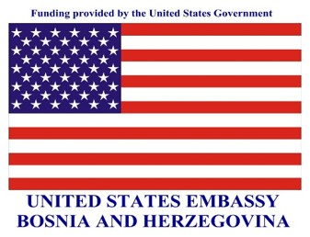

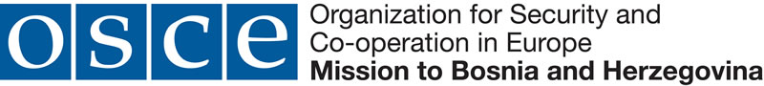

December 2020

Contents
1. SUMMARY OF THE REPORT 3
2. ABOUT 2020 LOCAL ELECTIONS IN CITY OF MOSTAR 4
3. LONG-TERM OBSERVATION OF ELECTIONS 6
3.1. Observation findings 6
3.2. Work of the electoral administration 9
3.3. Media, civil society, and citizens 11
4. METHODOLOGY OF THE LONG-TERM ELECTION OBSERVATION 12
5. ABOUT “STEP“ PROJECT AND COALITION “POD LUPOM” 13

1. SUMMARY OF THE REPORT

- The Local Elections in the City of Mostar are scheduled for December 20, 2020, first time after 12 years.
- 35 councillors are elected to the City Council at the Local elections, while the Mayor is elected indirectly from among the elected councillors.
- The right to vote in the Local elections will have 100 864 Mostar citizens.
- The number of voters registered to vote by mail is five times higher than in the last Local elections in Mostar in 2008.
- The Central Election Commission of BiH certified 32 political subjects and 368 candidates to participate in the elections.
- The electoral irregularities recorded during the pre-election and election period refer to misuse of the public resources, premature campaign, and inappropriate language in the public sphere.
- The election campaign in Mostar was characterised by a strong ethnic polarisation and raising interethnic tensions, calls for ethnic homogenisation under the pretext of the so called “dispersion of votes”.
- Senior public officials of the Republic of Croatia as well as BiH public officials are represented in the campaign of certain political subjects in BiH.
- In Mostar, like in other municipalities and cities in BiH during the regular local elections, many political subjects certified for participation in the election race have only one candidate, which leads to suspicion that this may be about the so called “phantom political subjects” and that the purpose is to trade seats on the polling station committees.

2. ABOUT 2020 LOCAL ELECTIONS IN CITY OF MOSTAR

The 2020 Local elections in the City of Mostar are scheduled for December 20, 2020. Councillors in the City Council of the City of Mostar are elected directly. Mayor of the City of Mostar is elected indirectly from among the elected city councillors.

The City Council of the City consists of 35 Councillors. A minimum of four (4) representatives of each Constituent People and one (1) of the Others shall be represented in the City Council. No Constituent People shall have more than fifteen (15) Councillors. The Councillors in the City Council are elected in seven (7) electoral constituencies, as follows:

- City electoral unit – 13 councillors
- Electoral unit of the city area 1 (North) – 2 councillors
- Electoral unit of the city area 2 (Old town) – 5 councillors
- Electoral unit of the city area 3 (Southeast) – 2 councillors
- Electoral unit of the city area 4 (South) – 2 councillors
- Electoral unit of the city area 5 (Southwest) – 7 councillors
- Electoral unit of the city area 6 (West) – 4 councillors

The Central Election Commission has certified 32political subjects (political parties, coalitions and/or independent candidates) to participate in the elections and 368 candidates. The right to vote in the Mostar Local elections will have 100 864 voters registered in the Central Voters' Register as of November 11, 2020. 3 985 voters registered to vote by mail.

A total of 154 polling stations have been formed whereof 150 are regular polls. 16 regular mobile teams have been formed for the voters who have registered and met the requirements for voting through a mobile team. Nine (9) Covid-19 mobile teams have been formed by the time of publication of this report, while the final number of these teams will be known after the Election Day.

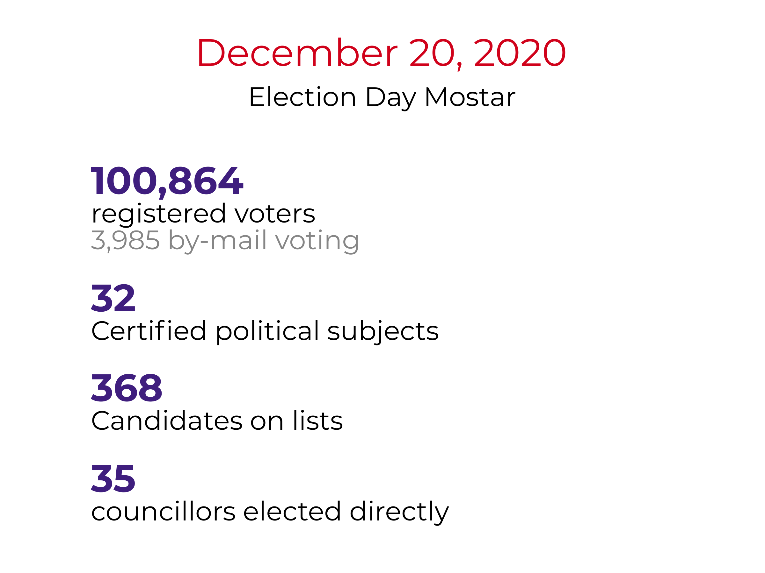
Infographic 1 – Summary of the 2020 Local Elections in Mostar

3. LONG-TERM OBSERVATION OF ELECTIONS

In the pre-election period, the Coalition “Pod lupom” observes work and sessions of the local election commissions in BiH, activities set forth by the election calendar and observance of the deadlines, electoral irregularities, and media reporting. The Coalition's observers reported 18 electoral irregularities in the Mostar local election race. These irregularities refer to nine (9) cases of the premature campaign, misuse of the public resources in 5 cases, in 4 cases the public language can be characterised as inappropriate in light of spreading religious, ethnic, and most frequently intolerance based on affiliation to another political option.

3.1. Observation findings
3.1.1. Election campaign

The Election Law of BiH defines the election campaign as a 30-day period before the Election day during which political subjects inform the voters and the public about their programs and candidates for the forthcoming elections. The election campaign for the 2020 Local Elections in the City of Mostar officially began on November 20, 2020. Any form of paid political advertising and pre-election activities of the political subjects is not allowed before this date except for the holding of internal gatherings of authorities and statutory bodies of the political subjects within the period between the day when elections are announced and the day of official start of the election campaign.

The pre-election period in Mostar, as in the rest of the country prior to the November 15 Local elections, was marked by the Covid-19 epidemic. The campaign moved to the virtual world of social media. The Coalition’s observers reported on the activities of the political subjects in terms of the premature campaign in nine (9) cases. What characterised the campaign in Mostar was a strong ethnic polarisation and the campaign based on raising inter-ethnic tensions, calls on ethnic homogenisation under the pretext of the so called “dispersion of votes.” It was recorded that ministers in the Croatian Government repeatedly, both directly and indirectly, endorsed one political subject - HDZ BiH, openly calling citizens to vote for this political subject.

Furthermore, it was recorded that the FBiH Prime Minister, acting in the capacity of his prime minister function and not the party function, as published on the web page of the SDA Mostar City Board, exclusively met the candidates of the Coalition for Mostar and their mayoral candidate where they discussed future investments.

3.1.2. Accuracy of the Central Voters' Register (CVR)
The voter registration in BiH has been passive since 2006, while active registration is still in place for voters who would like to vote abroad or from abroad. 100 864 voters are registered in the Central Voter's Register for the 2020 Local Elections in Mostar as of November 11, 2020. The Coalition's observers have not reported any suspicion in the accuracy of the voter's register; there was no major registration/deregistration of voters.

3.1.3. Out-of-country voter registration
The deadline for registration of voters for out-of-country voting was October 6, 2020. After this deadline, the CEC of BiH registered a total of 3 985 voters for the out-of-country voting, which is five times more than in the last local elections in Mostar in 2008 when 788 voters applied to vote by-mail.
For the 2020 Local Elections in BiH, the CEC rejected a total of 441 vote by-mail applications. Most of the rejected applications refer to submission of inappropriate proof of identity (174), failure to submit a valid proof of identification (90), lack of proof of residence (62) and several shortcomings in the application (61).

The Coalition notes that the CEC of BiH registered a total of 3 985 voters for out-of-country voting, which is five times more than in the last local elections in the City of Mostar in 2008.

Most of the voters registered to vote by mail come from the following countries: Germany (715), Serbia, (627), Norway (578), Sweden (411) and Croatia (378), the United States of America (226), Montenegro (202), Switzerland (173), Denmark (138) and Canada (113).

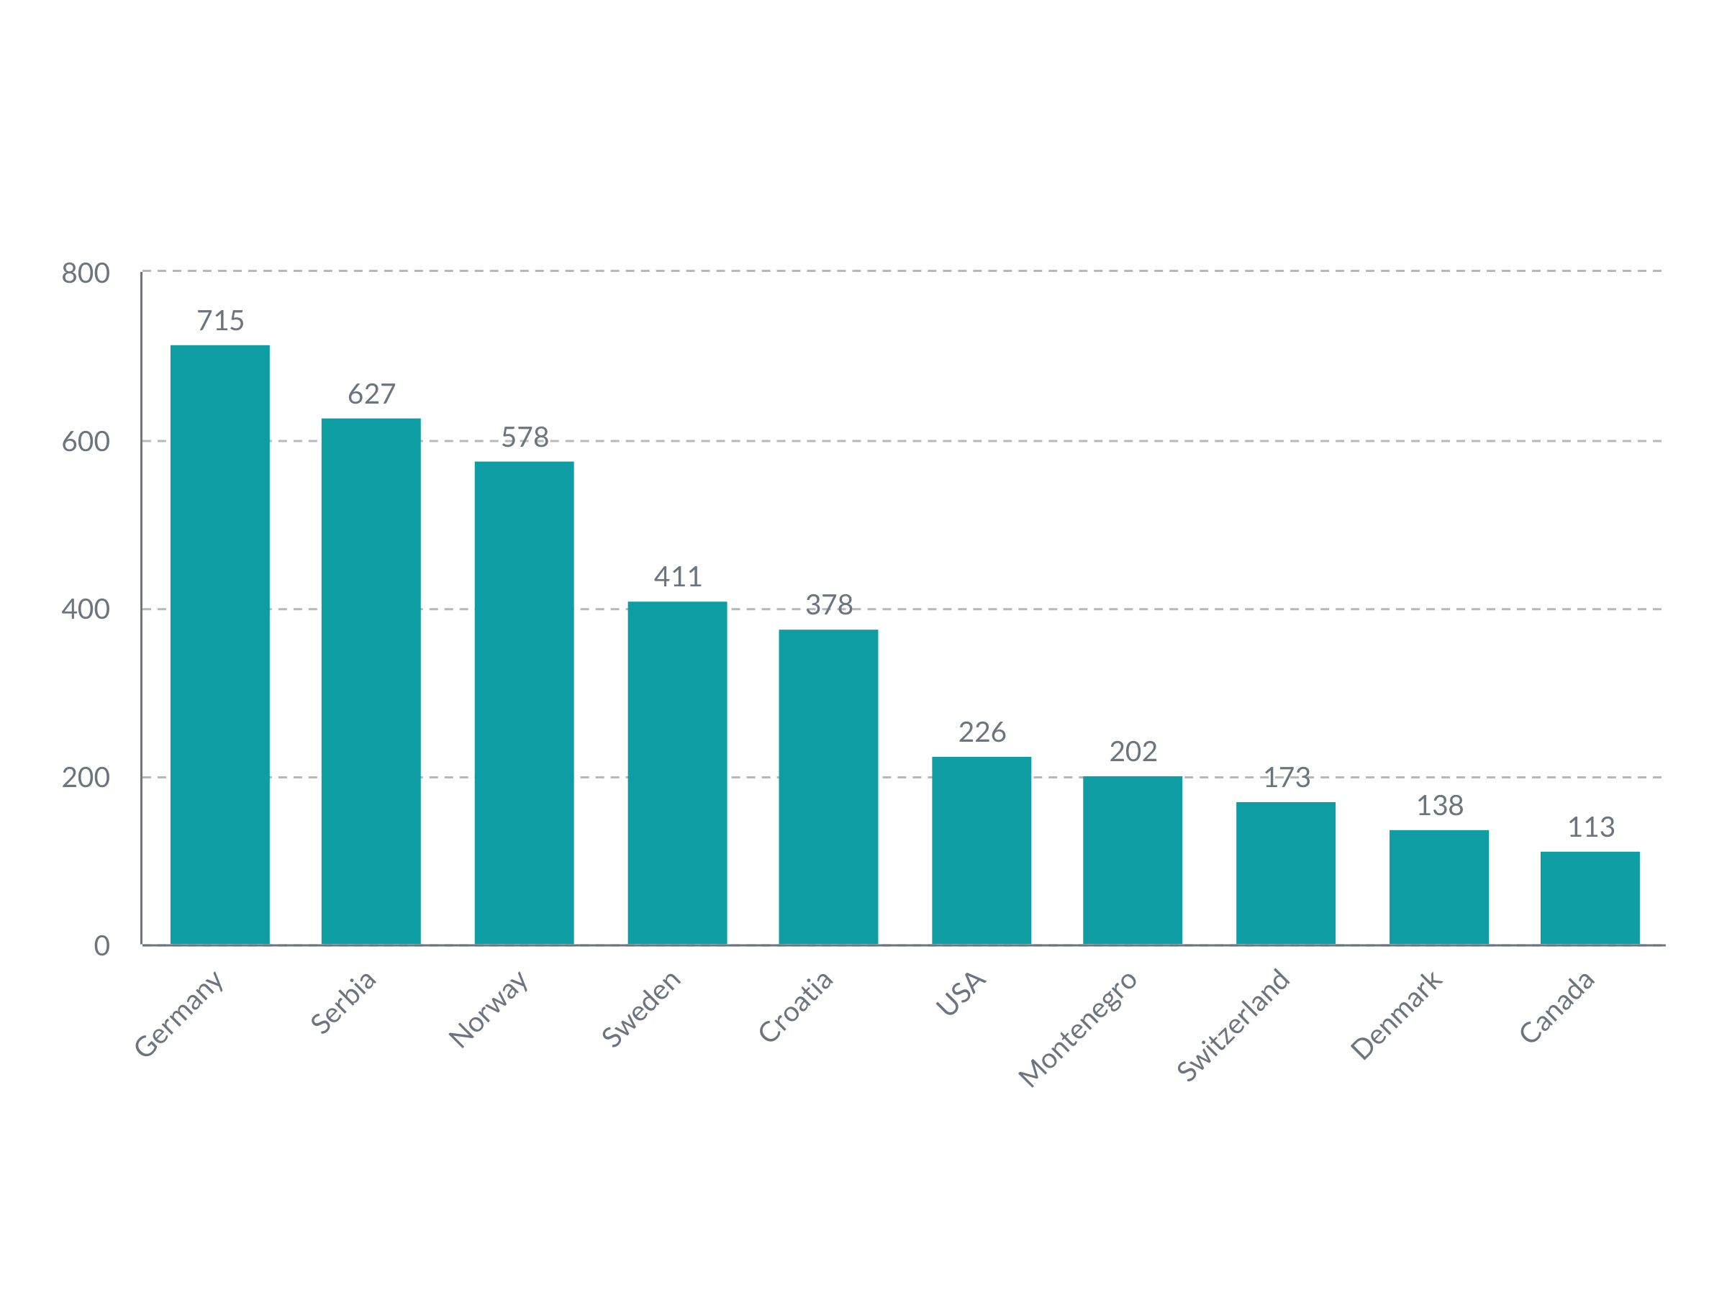
Graph 1 – Number of by-mail voting applications by countries (top 10)

3.1.4. Misuse of public resources and public office for election purpose
The misuse of the public resources and/or public office for election purposes includes spending public budget money and other money owned by BiH citizens and the misuse of public companies and appointed public offices by political subjects or individuals running for elections. Almost always, the misuse of the public resources is done by those who are entering the election race while already holding public office.

The Coalition's observers in Mostar reported five (5) cases of the misuse of public resources. These cases relate to intensification of the public infrastructure works and frequent and intensive visits by public office holders from higher government levels who typically meet or pay visits to local representatives of their own political parties. The reports relate to SDA and SNSD, i.e. the list “Stay here – together for our Mostar”. The Coalition’s observers reported on SNSD’s officials distributing presents to children on two occasions during the pre-election activities, which may represent abuse of children for political purposes.

3.1.5. Other irregularities
Inappropriate language, contents or language that could incite religious, national or any other intolerance, mostly related to affiliation to a political party, has been registered in 4 cases. In these cases, representatives of political subjects and even journalists used offensive language and ethnic labelling when analysing political events, which supports our assessment that the campaign of certain political subjects mostly targeted the ethnicity emotions of voters.
The Coalition was contacted by a citizen who got upset after finding in her mailbox promotional material that was identical to the ballot paper to be used on Election Day. The promotional material was distributed by the Coalition All for Mostar with instructions for how and for whom to vote. As regards this matter, the Coalition is in possession of Viber communication in which the SDA Mostar City Board Election Headquarters clearly indicates intention to come into possession of a ballot paper for electoral constituencies. The Coalition emphasises that there is no legal way for any political subject to come in possession of a ballot paper before the Election Day. It is alarming if print copies of the ballot papers are circulating in the public before the Election Day, because they may be abused on the very Election Day.
Analysis of the candidate lists in the Mostar elections shows the already seen situation where many political subjects that are certified for participation in the election race have only one candidate, which may lead to suspicion that this may be about trading seats on polling station committees. More specifically, 16 different political subjects have only one candidate at the level of the City electoral unit, even though they are certified for participation in the electoral areas.
The Coalition analysed the “critical polling stations“ in the City of Mostar in the previous 2018 General elections in BiH. It showed certain indicative anomalies in the electoral process (for example, turnout higher than 80%, candidates with 100% preferential/personal votes) and the irregularities recorded in the reports of the Coalition’s nonpartisan observers from the previous elections. It raises concern that as many as 41 polling stations in Mostar (27% of the total number of regular polling stations) were assessed as “critical“ because of the mentioned indications.

3.2. Work of the electoral administration

3.2.1. Central Election Commission of BiH
The Central Election Commission of BiH (CEC) is responsible for organization and conduct of all elections in BiH. After 12 years of not holding elections in Mostar and following the amendments to the Election Law of BiH, the CEC of BiH announced the elections for Mostar on July 23, 2020. The elections are scheduled for December 20, 2020.
The CEC of BiH monitors the deadlines for organisation and conduct of electoral activities. As the upcoming elections are taking place in the new emerging circumstances related to the Covid-19 epidemic, in June 2020 the CEC of BiH passed the Instruction on Operations of the Election Management Bodies on the Election day in the Context of the Covid-19 Epidemic. The instruction defines the procedures that should be applied on the Election day for the purpose of protecting the health and lives of representatives of the election administration authorities and voters. In addition the CEC of BiH has in September adopted amendment to the Rulebook on the procedure of conducting elections in BiH defining the method for organization and exercise of voting rights for persons positive for COVID-19 or persons in isolation/hospital, thus creating conditions for these persons to exercise their voting right as well.
However, the November 11 amendments 2020 brought new changes to the Rulebook allowing these categories of voters to exercise their voting right through a special mobile team if they in their application to the competent local election commission submit a relevant document issued by the competent authority (medical report or order to isolation). Considering voters' experiences in the November 15 local elections in terms of practical application of this Instruction, there is fear that a number of Mostar voters will be affected. During the regular November 15 Local elections in BiH, the Coalition received dozens of calls from voters who did not timely receive the certificate of isolation or the Covid-19 test result to be able to register for this type of voting. The Coalition also received calls from the voters registered for this type of voting but unable to cast their votes as the Covid-19 special mobile team never came to their homes.

3.2.2. Election Commission of City of Mostar
The election commissions at the local level (municipal, city, and election commission of Brčko District of BiH) are, inter alia, responsible for designation of polling stations, establishment and training of polling station committees, organization of the Election Day and consolidation of election results from the polling stations on their territory. The composition of the local election commissions, respecting the provisions of the BiH Election Law and the Gender Equality Law should reflect gender representation of at least 40% members of under-represented gender.
The Election Commission of the City of Mostar has 7 members; it operates in its full capacity. The Commission meets the gender requirement, as provided for by the Election Law of BiH.
According to LTOs' reports, the Election Commission of the City of Mostar implements the activities related to preparation and organisation of elections in accordance with the calendar of electoral activities. Instruction on the method of work and reporting of election commission of basic constituency in Bosnia and Herzegovina closely prescribes the functioning of the local election commissions. The instruction stipulates, inter alia, adoption of Rules of Procedures for local election commission, which was done by the Election Commission of the City of Mostar. The Commission has a Secretary, which is a possibility provided in the Instruction.
The Commission published a list of the appointed members of the polling station committees on the bulletin board. The way in which the decision was composed, i.e. placing codes of the political subjects instead of names prevents the public and voters from having insight in party membership/affiliation of members of the polling station committees. The Decision should be modified to stipulate disclosure of names of the political subjects and not their codes, to contribute to transparency of the electoral process.
The Coalition's observers recorded that two complaints had been filed with the Election Commission of the City of Mostar during the observed period – one for the premature campaign and the other one referred to the appointment of the polling station committee, which was rejected as unjustified.

3.3. Media, civil society, and citizens
The Coalition's long-term observers monitored reporting of the local and regional media and held meetings with civil society representatives at the local level. In that context, the Coalition’s observers reported that the media outlets reported on local elections and election’s participants in an unbiased manner, and that there were no recorded or reported cases of pressure on either the media or civil society.

4. METHODOLOGY OF THE LONG-TERM ELECTION OBSERVATION
The “Pod lupom” Coalition observes the entire electoral process in BiH in the 2020 Local elections. This implies all phases of the electoral process, from the day on which the elections are announced until the publication of final and confirmed elections results. For the purpose of observing the Mostar local elections, the long-term election observation was conducted from October 5, 2020. The long-term observation serves to monitor the overall electoral process to provide a comprehensive picture of the broadest possible spectrum of the election-related activities, not only the Election day-related activities.

The long-term observers in the city of Mostar observe the work and sessions of the Election Commission of the City of Mostar, the activities set forth in the electoral calendar, observance of the deadlines, electoral irregularities, and the media coverage. LTOs make weekly reports of their activities and have thus far sent 11 regular reports on the key findings of the observation efforts. The LTOs have thus far held 21 meetings with various actors of the electoral process (electoral administration, political subjects, institutions, police administration, civil society organizations, the media and others) with an aim of making an objective assessment of the electoral process in BiH. The LTOs' reports are a backbone of this preliminary report.

The Coalition Pod lupom will on Election Day have observers at all regular polling stations in Mostar, as well as in the Election Commission of the City of Mostar.

5. ABOUT “STEP“ PROJECT AND COALITION “POD LUPOM”

The Centres for Civic Initiatives (CCI), as the project Coordinator, together with the Centre for Civic Cooperation Livno, Forum of Tuzla Citizens, Association of Citizens "Democracy-Organization-Progress" Prijedor and Institute for Youth and Community Development "Perpetuum mobile" from Banja Luka, as the project partners, as part of Pod lupom – Coalition for Free and Fair Elections are implementing the System Transparency in Election Process (STEP) project funded by the European Union (EU) and cofounded by the Government of the United States of America and the Organization for Security and Cooperation in Europe (OSCE). The STEP project will directly increase the strength and visibility of the civil society organizations (CSOs) to perform citizen election monitoring and support the development of civil society participation in the democratization processes in the country, covering two election cycles in BiH: 2020 Local Elections and 2022 General Elections.

STEP is looking to strengthen civic participation and empower country – broad CSO movement to support the fair and free elections in Bosnia and Herzegovina, reducing the risk of electoral frauds and manipulations. Boosting citizen interest to take a proactive approach in expressing their free political will is what this project aims to actively contribute to, understanding that the elections represent the essential and most crucial form of citizen participation in democratization processes in the country.
STEP designed a set of activities divided under the 5 components, following the imperative of the CSO capacity building aiming to empower the civil sector to capacitate for further, stronger, and visible, sustainable local citizen election observation activities in the future. The STEP is consisted of the following five project components: 1) Capacity Building and Network Development, 2) Election Observation, 3) Policy Development and Advocacy, 4) Public Outreach and Voters’ Education and 5) Media Monitoring.
The Coalition for Free and Fair Elections “Pod lupom” as an informal coalition of civil society organizations has been active since 2014. Thus far the Coalition observed the 2014 General Election, the 2016 Local Election, the 2018 General Election, and 20 other elections (primary, early, repeated elections and mayoral recall elections). A total of around 10 000 civic observers were engaged in all elections. The Coalition has worked with 50 000 citizens, whereof 30 000 young people.

The Coalition's 14 recommendations have been either fully or partially adopted, which contributed to the improvement of the election process. The Coalition Pod Lupom was voted the most trusted actor in the electoral process according to IPSOS’s research from August 2018 (trusted more than the electoral administration, political parties, candidates, or media).

Besides the election observation, the Coalition conducts studies and prepares international comparative analyses. The Coalition monitors the sessions of the Central Election Commission of BiH (CEC), organizes roundtable conferences that bring together representatives of legislature, election administration, international and academic community, media, and civil society. The Coalition advocates improvement of electoral process in all of its segments. In addition to the aforesaid activities, the Coalition also educates young first-time voters during the election year to motivate and encourage them to actively participate in the election process.


The project is funded by the European Union

This publication is created with financial support of the European Union (EU).

The responsibility for the content of this document lies solely on the Coalition Pod lupom and does not reflect the official opinion of the European Union.

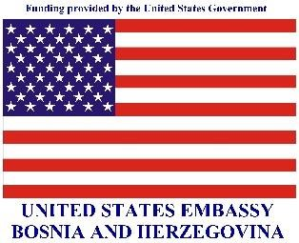

Publication of this report was funded in part by a grant from the United States Department of State.

The opinions, findings and conclusions stated herein are those of the authors and do not necessarily reflect those of the United States Department of State.

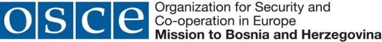

The OSCE Mission to Bosnia and Herzegovina supported publication of this material. Any view, statement or opinion expressed in the publication, unless explicitly specified, do not necessarily reflect the official position of the OSCE Mission to BiH.

23 political parties, 4 coalitions, 4 independent candidates, and 1 list of independent candidates.
96 797 voters have registered to vote at the regular polling stations, 48 voters have registered for voting in absentia there are 34 voters registered for voting at the polling stations marked with “in person, and 3 985 voters registered to vote by mail.
SDA, DF and SDP two cases each; HDZ BIH, Party for BiH, and SBB one case each;
96 797 voters have registered to vote at the regular polling stations, 48 voters have registered for voting in absentia; there are 34 voters registered for voting at the polling stations marked “in person“, and 3 985 voters registered to vote by mail.
The remaining applications were received from the following countries:: Australia (47), Austria (83), Belgium (18), Bolivia (1), Bulgaria (1), Czech Republic (8), Egypt (1), Finland (4), France (61), Greece (5), Ireland (5), Italy (43), Israel (2), Jordan (5),South Korea (1), Lichtenstein (1), Luxembourg (14), Hungary (1), Malesia (1), the Netherlands (78), New Zealand (1), Poland (3), Russia (2), North Macedonia (2), Slovenia (12), Spain (19), Turkey (6), United Arab Emirates (2), Great Britain (31).
A-SDA, Čapljina Independent List – Čapljina in the heart, BH Democrats – Džebrail Bajramović, Alliance for the Old Town, BOSS Mirnes Ajanović, Independent List Doboj, NBL, Left Wing, Alliance of Young Forces, Movement Bridge 21, Liberal Party BiH, HKDU BiH, LDS BiH, HSP dr Ante Starčević, HDU BiH, HSS Stjepan Radić
The Law on Changes and Amendments to the Election Law of BiH, the Official Gazette of BiH 41/20

